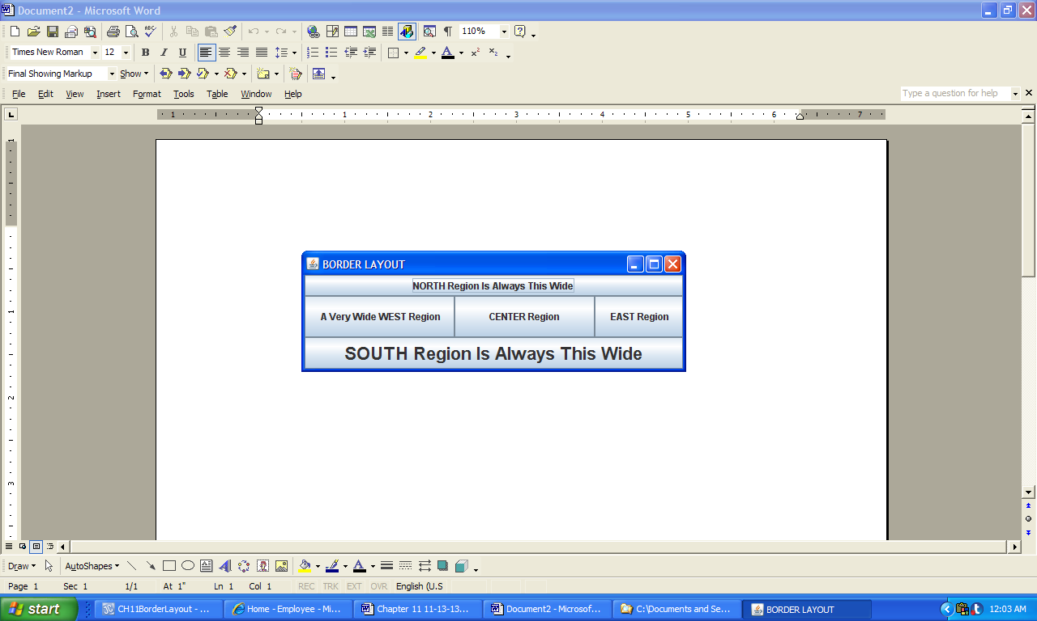

**Figure 11.31 The positioning and sizing of the five border layout regions.**